Phone and Social Media Contract
Please initial your agreement after each statement.

1. We are letting you have a phone. Remember a phone is not a necessity; yet, we are willing to allow you to have one. Aren’t we the greatest? ___

2. We will always know your phone and social media passwords. Always.___
3. Don’t let the anonymity of social media lure you into saying or doing something you wouldn’t normally do. People still have feelings online, and you shouldn’t underestimate the power of your words.
4. Hand the phone to one of your parents promptly at 8:30 p.m. every school night and every weekend night at 9:30 p.m. It will be shut off for the night and turned on again at 7:30 a.m. ___
5. It may go to school with you, BUT, converse with your friends in person. It's a life skill. ___
6. If it falls into the toilet, smashes on the ground, or vanishes into thin air, you are responsible for the replacement costs or repairs. Mow a lawn, babysit, stash some birthday money. It will happen, you should be prepared. Consider a savings plan now. ___
7. Do not use this technology to lie, fool, or deceive another human being. Do not involve yourself in conversations that are hurtful to others. Be a good friend first or stay out of the crossfire. ___
8. Do not text, email, or say anything through this device you would not say in person. ___
9. Do not text, email, post, or say anything to someone that you would not say out loud with parents in the room. Censor yourself. ___
10. Don’t search or post anything that you wouldn’t feel comfortable sharing with us. ___
12. Do not send or receive pictures of your private parts or anyone else's private parts. Don't laugh. Someday you will be tempted to do this despite your high intelligence. It is risky and could ruin your teenage/college/adult life. It is always a bad idea. Cyberspace is vast and more powerful than you. It is hard to make anything of this magnitude disappear; including a bad reputation. ___
13. Don't take a zillion pictures and videos. There is no need to document everything. Live your experiences. They will be stored in your memory for eternity. ___
14. Don’t get involved in other people’s drama even if they’re your BFF’s! Don’t let their issues consume your time. ___
15. If someone says something rude, mean, or inappropriate about you on social media, do NOT respond! Talk with us first so we can give you direction. Retaliating on social media will only make it worse. ___
18. You will mess up. We will take away your phone. We will sit down and talk about it. We will start over again. You, your mom and dad are always learning. We are on your team. We are in this together. ____
I have read and fully understand all 18 points above. I will not act out or give attitude when I break a rule and consequences (that I don’t agree with) are given.
____________________________________________________________________
SIGNATURE DATE
____________________________________________________________________
PARENT SIGNATURE DATE
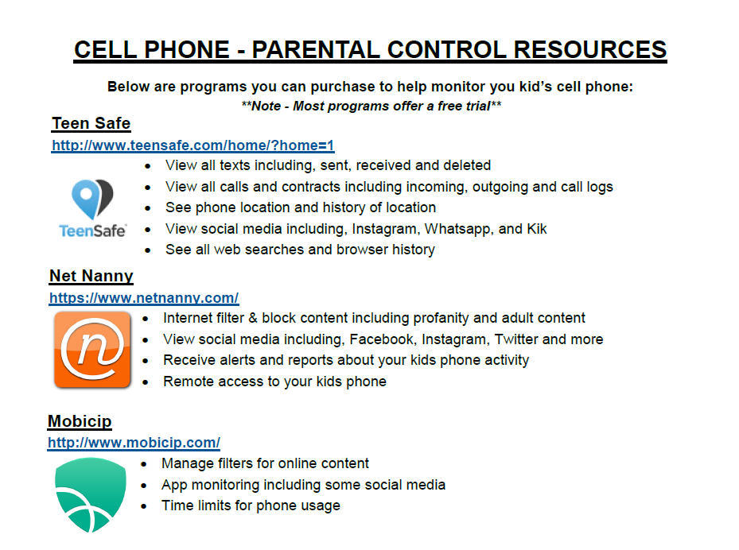
Qustodio – http://www.qustodio.com/en/ -Free option.
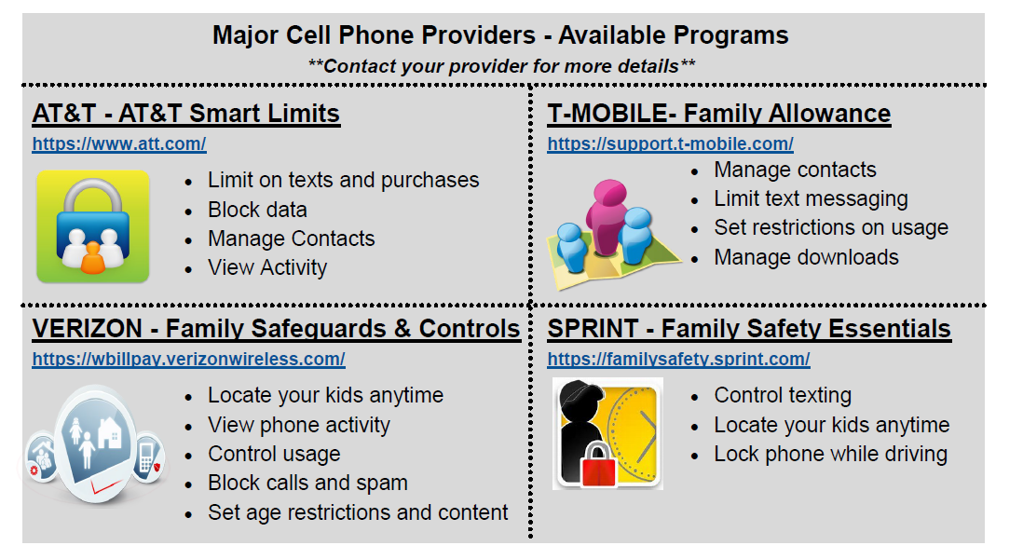
Description of Popular Social Media Apps
- Ask.fm & Sarahah
  - Social networking apps set up in an anonymous question and answer format. Ask.fm is less popular, but Sarahah is becoming bigger and bigger. The anonymity makes people feel comfortable saying things they wouldn’t normally say. Both of these apps have age restrictions, which teens can easily get around. There is no reason your teen needs either of these apps.
- Instagram
  - Mobile, desktop, and internet-based photo-sharing application and service that allows users to share pictures and videos either publicly or privately. It is a search engine for billions of images…which could involve cute cuddly cats, or explicit imagery. Instagram can bypass adult content filters as it is an app. Make sure you enable the “Posts are Private” setting under the “Edit Profile”. Cyberbullies often create fake accounts claiming to be the “victim”, and then post embarrassing photos to further the bullying.
- Snapchat
  - Snapchat is a mobile app that allows users to send and receive "self-destructing" photos and videos. Photos and videos taken with the app are called snaps, and can be recovered after they “self-destruct”. Snaps can also be screenshotted, although the senders are now alerted if a screen shot is taken. The idea that the photo goes away is simply not true, and so many teens have sent inappropriate photos believing there would be no push back. Snapchat Story allows users to post photos to their “story” that can be viewed for up to 24 hours. This is being used more and more as a means to victimize other teens.
- Twitter
  - Online social networking tool where users sign-up to receive and send extremely brief content – known as tweets – with others. Basically it’s a way to share thoughts, ideas, and opinions in up to 140 characters. Twitter can be used to connect people with similar interests through the use of hashtags - # -. Twitter is a place where students feel they can diary their feelings, not realizing their Tweets are tied to their identity and are able to be seen by colleges, employers, other students, and predators. We suggest that students stick to sharing positive content that they would feel comfortable with anyone seeing.

- Kik Messenger
  - Commonly called Kik, is a freeware instant messaging mobile app. Like Instagram, Snapchat and other messaging rivals, Kik provides free, easy and instant connections to other users anywhere. Kik enables people to message each other one-on-one or in group chats, and to share photos, videos and other content. The app grants users anonymity by enabling people to identify themselves only by an invented username. Teens will often share their Kik username on their Instagram, which predators and cyberbullies will use to anonymously instant message your child. The app allows searches by age and lets users send photos that aren’t stored on phones. It’s popular with tweens and teens — and predators.
- YouTube
  - You may have heard your child talk about being “YouTube famous” as more and more teens are heading to this search engine to post and search for videos. While YouTube can be a fantastic app/website for finding tutorial videos on how to do everything from styling your hair to fixing a toilet, there is also a great detail of inappropriate content. Parents can enable filters to prevent your student from seeing this content. Comments toward your child’s videos can also be disabled. We highly suggest this to prevent “trolls” from virtually berating your child’s video. “Trolls” is a term used to refer to people who purposely go out of their way to post negative comments with the hope of getting a reaction from the user.
- ooVoo & Houseparty
  - These apps feature free video and voice services for up to 20 users. Used properly, this can be a great way to form a study group and collaborate on projects with other students. However, once someone makes their username, they cannot change it, and if the user posts this information on another social media app it is easy for anyone to directly contact your child. They could get a video chat request from a complete stranger. This can be avoided by switching the account to private.
- Other Resources
  - Smart Social - https://smartsocial.com/app-guide-parents-teachers/
    - This website breaks down the most popular social media apps into three categories based on how safe they are. We recommend parents visit this site as a starting point to evaluate which apps your child should have.

